LAB ASSIGNMENT_01
Date:-05/01/2026

Name:-Sudhanshu Kumar
Roll_No:-UG/02/BTCSECSF/2023/024
Reg_No:-AU/2023/0010451
Section:-“E”
Q1. Create a database named collegeDB and switch to it.
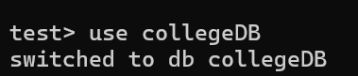
Q2. Create a collection named students in the collegeDB database.
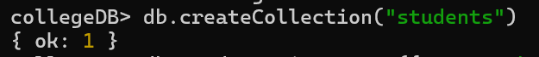
Q3. Insert one document into the students collection with the following fields:
• name
• rollNo
• department
• age
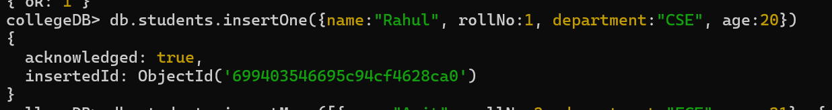

Q4. Insert four more documents into the students collection with different values.
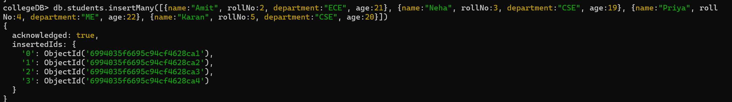

Q5. Display all documents present in the students collection.
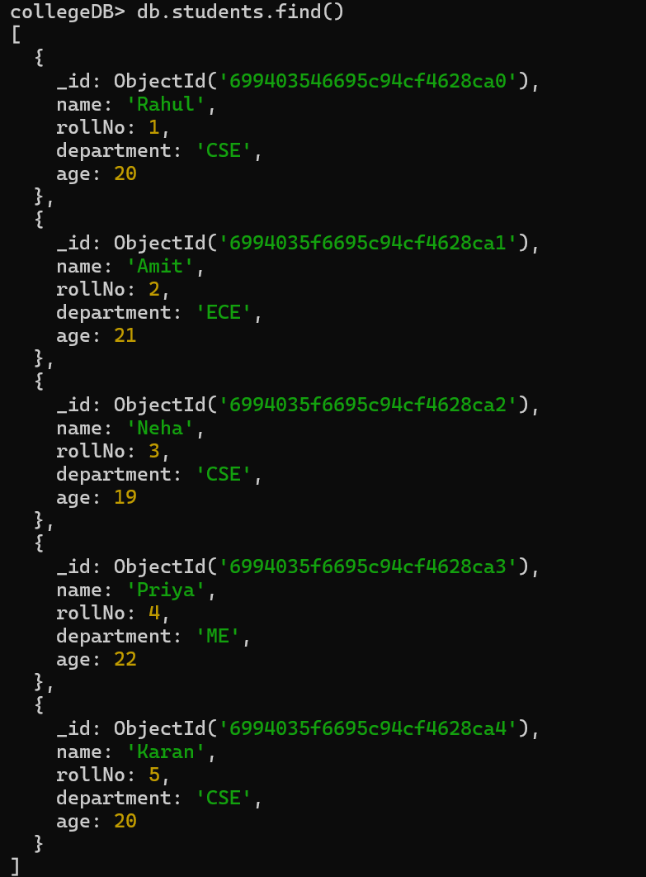

Q6. Display only those students who belong to the CSE department.
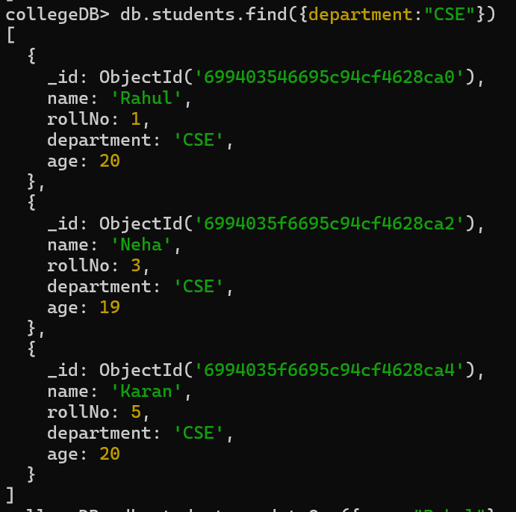

Q7. Update the age of one student (any one) to a new value.
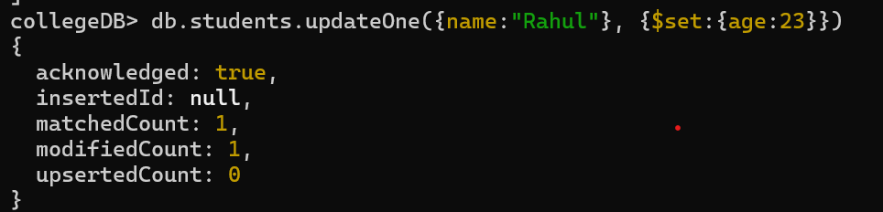

Q8. Delete one document from the students collection using any condition.
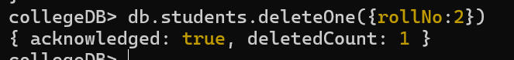
MONGODB COMPASS
